**NIEM Business Architecture Committee (NBAC) Governance**

This document amplifies the [NIEM OASIS community governance](https://github.com/NIEM-OASIS-DRAFT/oasis-open-project/blob/main/GOVERNANCE.md) document. It incorporates all provisions of that document. In case of conflict, that parent document controls. This document changes infrequently by the process defined below.

**NBAC Technical Steering Committee (TSC) Scope**

The scope of the NBAC Technical Steering Committee (TSC) is to coordinate, harmonize and unify NIEM Domain’s content as it relates to the NIEM data model and the code-list, safeguard NIEM data model core content, identify, validate and on-board new NIEM domains as well as advise, and support the Project Governance Board (PGB) on matters relating to business architecture and requirements of NIEM. The NBAC shall:

* + Facilitate the construction, maintenance, and use of a business architecture framework, model, code, and other NIEM related documentations
  + Manage the harmonization process, issue resolution mitigation, and development and packaging of release candidates
  + Provide management and oversight of the NIEM core, the central part of the NIEM data model that is commonly understood across all domains
  + Serve as the forum for NIEM domains and interactions between domains and communities to coordinate content, data model, and code list
  + Establish (or dissolve) tiger team and/or subcommittees to help solve complicated data sharing issues or close gaps on mission critical data sharing issues or opportunities
  + On-board new NIEM Domains and ensure new NIEM data model content candidates are properly vetted and verified
  + Provide NIEM training
  + Document standard operating procedures
  + In coordination with the NTAC TSC, shepherd the release candidate through the PGB evaluation and acceptance process
  + Assess NIEM Domain maturity, vitality, and health and provide remediation support if needed.

**Composition**

NBAC membership includes the NBAC chair/co-chairs, domain stewards, voting members, at-large members, NIEM Technical Architecture Committee (NTAC Co-chairs) TSC Maintainers, NBAC PGB liaison, tiger teams, and subcommittees (Figure 1). NBAC TSC members must execute Contributor License Agreements (CLAs). The NBAC chair/co-chairs may invite non-member observers and guests to participate in activities on a temporary basis.

**NBAC Chair/Co-chair** - The NBAC TSC nominally has two co-chairs. The NBAC co-chairs are appointed by the PGB via a call for nominations. Nominees for the NBAC co-chairs can be submitted by any individual to the PGB. The NBAC co-chairs serve nominal 2-year terms or until they voluntarily resign or are recalled by the PGB. If feasible, co-chair terms should be staggered to provide continuity.

Nominees for the NBAC are approved without dissent and participate until they voluntarily resign. Members and their sponsoring entities must submit CLAs.

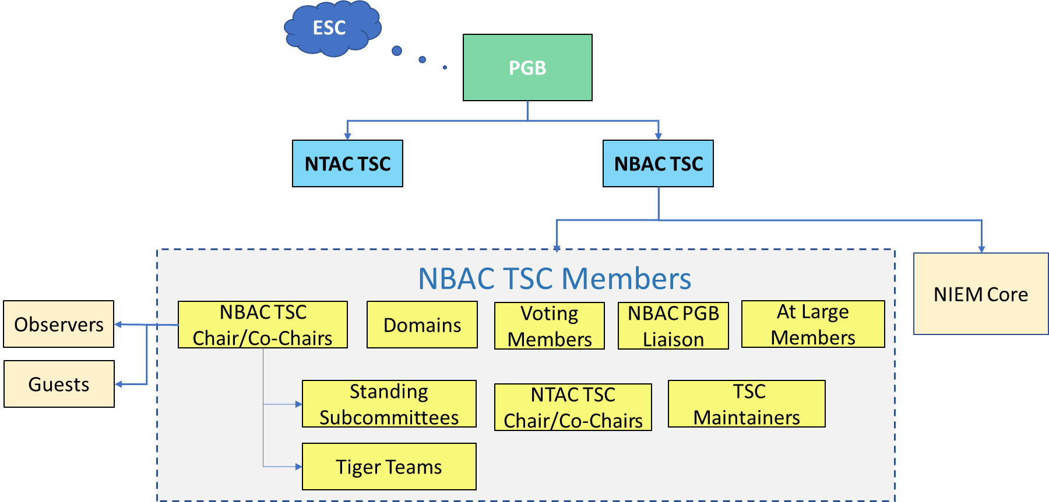

Figure Governance Organization Chart

**NIEM Domains -** NIEM domains are formally established communities of Interest (CoI) with executive stewards to represent the stakeholders, governance, and data model content and context oriented around their respective business (functional) needs. Domains manage reusable, community-specific content and context and participate in NIEM governance at large. Each domain represents individuals and organizations that span all levels of government, industry, and the international community.

**Domain Stewards -** The Domain Steward (s) is the executive responsible for the governance, management, operations, and model content including maintenance of their unique code-list of a NIEM Domain. The role may be shared between Domain co-chairs.

Stewards are appointed by the Domain sponsoring organization (s) leadership unless otherwise specified in the domain charter. Stewards require the endorsement of the NBAC.

**Voting Members** – The NBAC voting members include:

* NBAC co-chairs
* Domains are allowed two voting members appointed by the domain steward or as specified in a domain charter.

**At Large Members –** NIEM stakeholders/Communities of Interest (CoI) unaffiliated with a specific domain may participate as At Large members. CoIs are groups of people who share a common concern, set of problems, or interest in a topic and eventually come together based on the need to exchange information. Members need not be aligned to a formal domain to create NIEM exchanges or participate in the NBAC TSC.

**TSC Liaison -** The NBAC TSC Liaison to the PGB is appointed by the NBAC TSC co-chairs with consent of the PGB. Nominees can be submitted by any individual. The NBAC TSC Liaison serves a nominal 2-year renewable term at the discretion of the NBAC co-chairs.

**TSC Maintainer -** When a NBAC TSC Maintainer (hereafter referred to as NBAC Maintainer) is appointed to manage a NBAC GitHub repository, that Maintainer may serve in the dual role as TSC Liaison.

**Responsibilities**

**Co-Chairs -** The NBAC co-chairs are delegated the following responsibilities

* Appoint a TSC Liaison to the PGB
* Appoint a TSC Maintainer if a separate NBAC TSC repository is established
* Establish tiger teams and standing subcommittees
* Conduct regular NBAC meetings, creating or approving the agenda and directing the business of the meeting. The co-chairs shall exercise their executive discretion in bringing items before the committee for a vote
* Ensure that meeting minutes, including lists of attendees, and any assignments, decisions, or votes taken are compiled and sent to the mailing list
* Draft NIEM Open Project Annual Report
* Develop an NBAC annual Work Plan reflecting PGB priorities
* Track accomplishment of Work Plan and committee tasks
* Document committee membership, maintaining a current mailing list
* Maintain a roster and mailing list of committees voting members
* Conduct outreach activities to identify new domains and NIEM adopters
* Onboard new domains
* Enforce committee voting rules and ensure that voting members can cast a vote
* Supervise domain participation in the [model harmonization](https://www.niem.gov/about-niem/niem-model) process
* Supervise domain participation supporting release candidates.

**Domain Steward -** The domain steward shall

* + Appoint domain voting members (2 maximum). Voting members should be
  + Experienced with NIEM
  + Familiar with harmonization and release cycle processes
  + Understand OASIS rules and NIEM Open governance
* Maintain a data dictionary of common elements and their related code-lists
* Maintain a domain roster and mailing list
* Perform outreach to domain COI stakeholders
* Draft, publish, and maintain procedures for domain governance and the processes related to domain data model and code list release management
* Participate in domain content harmonization and reconciliation activities supporting the NIEM release cycle
* Provide domain support to the NBAC TSC including annual reporting of progress, plans, requirements, and achievements
* Provide Domain support to the NIEM Technical Architecture Committee (NTAC) TSC production of technical specifications, requirements, tools, and associated artifacts.
* Provide ongoing identification of data requirements based on data exchange modeling and development efforts.

**Voting Members -** voting members shall

* + Attend TSC meetings or provide a temporary proxy
  + Participate in voting in a timely fashion.

**TSC Liaison –** TSC liaison shall

* + Attend TSC and PGB meetings or provide a temporary proxy
  + Participate in PGB voting in a timely fashion.

**At Large Members –** At large members shall

* + Attend TSC meetings
  + Serve on tiger teams and standing subcommittees
  + Participate in harmonization and release cycle activities.

**Decisions**

For most decisions, the NBAC operates by [lazy consensus](https://community.apache.org/committers/lazyConsensus.html). The NBAC may, at its own discretion, delegate authority on minor decisions to Maintainers in the community, NBAC tiger teams, standing subcommittees or members

* NBAC acceptance of Harmonization Process recommendations
* Endorsing NIEM award nominations for PGB approval
* Approving the NBAC Annual report.

Decisions on the following items must be made based on a [Simple Majority Vote](https://www.oasis-open.org/policies-guidelines/oasis-defined-terms-2018-05-22#dSimpleMajority)

* Nominating new domains for PGB approval
* Approving minor release candidates for submission to PGB
* Approving major release candidates for submission to PGB
* Recommending work to the PGB for promotion to the standards track
* Appointment of new Maintainer

**AMENDMENTS**

This NBAC TSC governance document may be amended by a simple majority vote of the NBAC with consent of the PGB. NBAC meetings at which a proposed amendment to governance is considered must be scheduled at least one week in advance of the vote, and the co-chairs must make a good faith effort to inform the NBAC of the meeting. Proposed amendments may be submitted to the co-chairs and will be considered by lazy consensus. A simple majority of voting members is needed to forward amendments to the PGB.